Tail dependence: EURUSD and USDCAD
Method 19 / daily log returns / alpha=0.05 / Alpari D1 full available history

Study setup
Logical pair: EURUSD , USDCAD
Broker symbols: EURUSD_i , USDCAD_i
Snapshot: 2026-11-03_majors_alpari_D1
Timeframe: D1
Matched return window: 1999-01-05 to 2026-11-02 (UTC bar dates)
Matched return count n: 7188
Dropped unfinished last bar dated 2026-11-03 UTC after a tick-volume check against the prior complete day.
Uniforms: ranks/(n+1); alpha=0.05
Complete matched rows (Excel): EURUSD-USDCAD_Tail_D1.xlsx
Complete matched rows (HTML table): EURUSD-USDCAD_Tail_D1_data.html

Method carried forward
Tail dependence counts how often both legs sit in an extreme uniform tail together. Matched daily log returns of close, ln(close_t / close_t-1), become u_i = rank(x_i)/(n+1) and v_i = rank(y_i)/(n+1). At alpha=0.05, lower L_hat = (# u<=alpha and v<=alpha) / (# conditioning leg <= alpha); upper uses >= 1-alpha. Both conditioning directions are reported with numerator and denominator counts. Quotes are not inverted. L_hat(0.05) is a finite-sample frequency, not the asymptotic lambda. Same-sample Pearson r is a side check. This is not causation and not a trading signal.

Results
tail | cond | L_hat | num | denom
lower | USDCAD | 0.008357 | 3 | 359
lower | EURUSD | 0.008357 | 3 | 359
upper | USDCAD | 0.011142 | 4 | 359
upper | EURUSD | 0.011142 | 4 | 359
Pearson r on returns: -0.456626

Conclusion
Over 7188 matched daily rows for EURUSD and USDCAD at alpha=0.05, lower L_hat conditioning on USDCAD is 0.0084 (3/359); conditioning on EURUSD is 0.0084. Upper L_hat conditioning on USDCAD is 0.0111; on EURUSD is 0.0111. Pearson r = -0.4566. These are finite-sample frequencies, not asymptotic lambda and not a trading signal.

Charts
Daily closes

Daily log returns

Uniforms with alpha lines
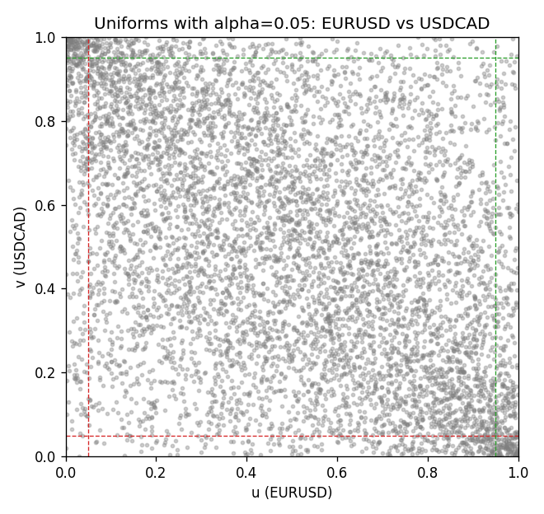

Data report
Every matched row is stored in the sibling Excel workbook named EURUSD-USDCAD_Tail_D1.xlsx, including u and v. Embedding all rows as a Word table is impractical; this file holds column summaries and the first and last 15 matched rows.
Columns: time, EURUSD_open, USDCAD_open, EURUSD_high, USDCAD_high, EURUSD_low, USDCAD_low, EURUSD_close, USDCAD_close, EURUSD_tick_volume, USDCAD_tick_volume, EURUSD_spread, USDCAD_spread, EURUSD_real_volume, USDCAD_real_volume, EURUSD_log_return, USDCAD_log_return, u, v
Column summaries (matched calculation rows)
column | count | mean | std | min | 25% | 50% | 75% | max
EURUSD_open | 7188 | 1.1814345 | 0.15078289 | 0.8272 | 1.086195 | 1.16617 | 1.2939425 | 1.5995
USDCAD_open | 7188 | 1.2667783 | 0.16890181 | 0.9168 | 1.1183975 | 1.298465 | 1.37211 | 1.6183
EURUSD_high | 7188 | 1.1865652 | 0.15138546 | 0.8326 | 1.0902775 | 1.17128 | 1.2993025 | 1.6038
USDCAD_high | 7188 | 1.2716763 | 0.16885945 | 0.9336 | 1.12285 | 1.30387 | 1.37649 | 1.619
EURUSD_low | 7188 | 1.1764236 | 0.15010221 | 0.8227 | 1.0820675 | 1.16257 | 1.2883725 | 1.5865
USDCAD_low | 7188 | 1.26222 | 0.16893673 | 0.9056 | 1.114065 | 1.293535 | 1.367805 | 1.6102
EURUSD_close | 7188 | 1.181473 | 0.1507571 | 0.8267 | 1.0860725 | 1.166175 | 1.2939575 | 1.5997
USDCAD_close | 7188 | 1.2667932 | 0.16887388 | 0.916 | 1.118295 | 1.29844 | 1.372365 | 1.6137
EURUSD_tick_volume | 7188 | 103177.84 | 173518.96 | 218 | 9407.75 | 52764 | 99553.25 | 1471626
USDCAD_tick_volume | 7188 | 81016.727 | 147303.02 | 37 | 5545 | 40941.5 | 71627 | 1410818
EURUSD_spread | 7188 | 19.349471 | 16.556644 | 0 | 8 | 12 | 30 | 50
USDCAD_spread | 7188 | 23.444073 | 18.266035 | 0 | 9 | 17 | 40 | 60
EURUSD_real_volume | 7188 | 4.031926e+10 | 1.6689501e+11 | 0 | 0 | 0 | 0 | 3.6149665e+12
USDCAD_real_volume | 7188 | 1.8376704e+10 | 9.6688094e+10 | 0 | 0 | 0 | 0 | 2.5751613e+12
EURUSD_log_return | 7188 | -7.59e-06 | 0.00580128 | -0.03123819 | -0.0032472 | 0 | 0.00325412 | 0.03433183
USDCAD_log_return | 7188 | -1.518e-05 | 0.00514306 | -0.03859748 | -0.00283637 | 4.741e-05 | 0.00272353 | 0.03436319
u | 7188 | 0.5 | 0.28865505 | 0.0001391 | 0.25006955 | 0.49923494 | 0.74993045 | 0.9998609
v | 7188 | 0.5 | 0.28865505 | 0.0001391 | 0.25006955 | 0.5 | 0.74993045 | 0.9998609
First 15 matched rows (selected columns)
time | EURUSD_log_return | USDCAD_log_return | u | v
1999-01-05 | -0.0048360507 | -0.010131666 | 0.16914731 | 0.026846571
1999-01-06 | -0.011547966 | -0.0003306769 | 0.028237585 | 0.46432049
1999-01-07 | 0.0076280636 | 0.0015202092 | 0.91932119 | 0.65210739
1999-01-08 | -0.010902799 | -0.0020495197 | 0.03268883 | 0.30449298
1999-01-11 | -0.007103287 | -0.0035137769 | 0.096258172 | 0.2079566
1999-01-12 | 0.0045103728 | 0.0066194721 | 0.81930728 | 0.92474614
1999-01-13 | 0.010845346 | 0.0045420214 | 0.96661566 | 0.85561274
1999-01-14 | 0 | 0.0069376546 | 0.49923494 | 0.93184031
1999-01-15 | -0.010153245 | -0.0056905671 | 0.040061205 | 0.10752539
1999-01-18 | 0.0036256946 | 0.00098344542 | 0.77465572 | 0.59771874
1999-01-19 | -0.00017235436 | 0.002748513 | 0.48421199 | 0.7519822
1999-01-20 | -0.0031939256 | -0.0059646885 | 0.25372096 | 0.0990402
1999-01-21 | 0.0030215416 | -0.0042823796 | 0.73584643 | 0.16219224
1999-01-22 | -0.0012075213 | 0.0025057712 | 0.39337877 | 0.73417722
1999-01-25 | -0.0030251979 | 0.00085579808 | 0.26331896 | 0.58575602
Last 15 matched rows (selected columns)
time | EURUSD_log_return | USDCAD_log_return | u | v
2026-10-13 | 0.0037402957 | -0.0046395653 | 0.7817499 | 0.14939491
2026-10-14 | -0.0037582255 | 0.0015184751 | 0.22423146 | 0.65196828
2026-10-15 | 0.0056053107 | -0.0036101503 | 0.86576714 | 0.20211434
2026-10-16 | 0.0017724895 | -0.0034322068 | 0.64960356 | 0.21352066
2026-10-19 | -0.0025394633 | -0.0018835331 | 0.29628599 | 0.31895952
2026-10-20 | 0.0023881672 | -0.0037066008 | 0.6932814 | 0.19515927
2026-10-21 | -0.00032046717 | -0.00084691787 | 0.47155376 | 0.41410488
2026-10-22 | -0.0015949606 | -0.0026307268 | 0.36375017 | 0.26540548
2026-10-23 | -0.001338521 | 2.85545e-05 | 0.38280707 | 0.49909584
2026-10-26 | -0.0022706559 | 5.7106554e-05 | 0.31325636 | 0.50104326
2026-10-27 | -0.004152342 | 0.0025379458 | 0.20100153 | 0.73751565
2026-10-28 | 0.0022262927 | -0.0038379274 | 0.683127 | 0.18556127
2026-10-29 | 0.0022571351 | -0.00011436495 | 0.68576993 | 0.48449019
2026-10-30 | -0.0011458446 | -0.0010298736 | 0.39866463 | 0.3957435
2026-11-02 | 0.002120569 | 0.00061519094 | 0.67672833 | 0.56099597

